Social Studies Home Learning Activities

Standard Benchmark | Students will demonstrate the skills necessary for participating in a group, including defining an objective, dividing responsibilities, and working cooperatively.
Grade Band | K-3
Vocabulary/Key Concepts | participating in groups, defining an objective, dividing responsibilities, working cooperatively, consequences

Dimmy and Swimmy

Focus Question: Is it better to work alone or cooperatively in groups?

Introduction
There are many times when people have to decide whether they should work alone or in a group. Sometimes it is better to work alone. Sometimes it is better to work in a group. Can you think of times when it might be better to work alone or in a group?
When people decide to work in a group, each person in the group should work cooperatively. Cooperation happens when people work well together to get something done. That something might involve a job, a chore, an assignment, or solving a problem. If people do not cooperate, the problem might not be solved, or the job completed.

Activity 1 (Day 1): Read or Listen to the Story of Dimmy.

Directions: You are about to read or listen to a story about a fish named Dimmy.

The main characters in the story are…

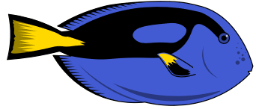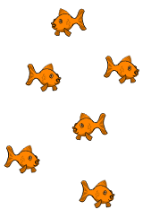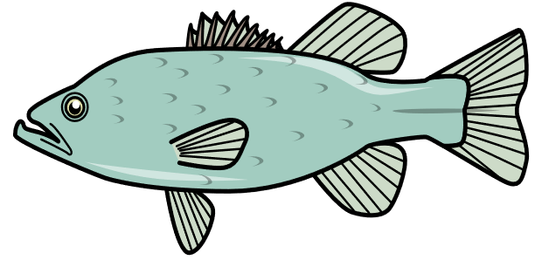
Dimmy The Little Fishies “Tuni” the Big Fish

As you read or listen to the story, think about the following:

- Are Dimmy and the little fishies in the story working alone or as a group?

- Are Dimmy and the little fishies in the story working cooperatively?

- What are the consequences of their choices?
Dimmy
Written and illustrated by Fran O’Malley (a “little fish”)

1
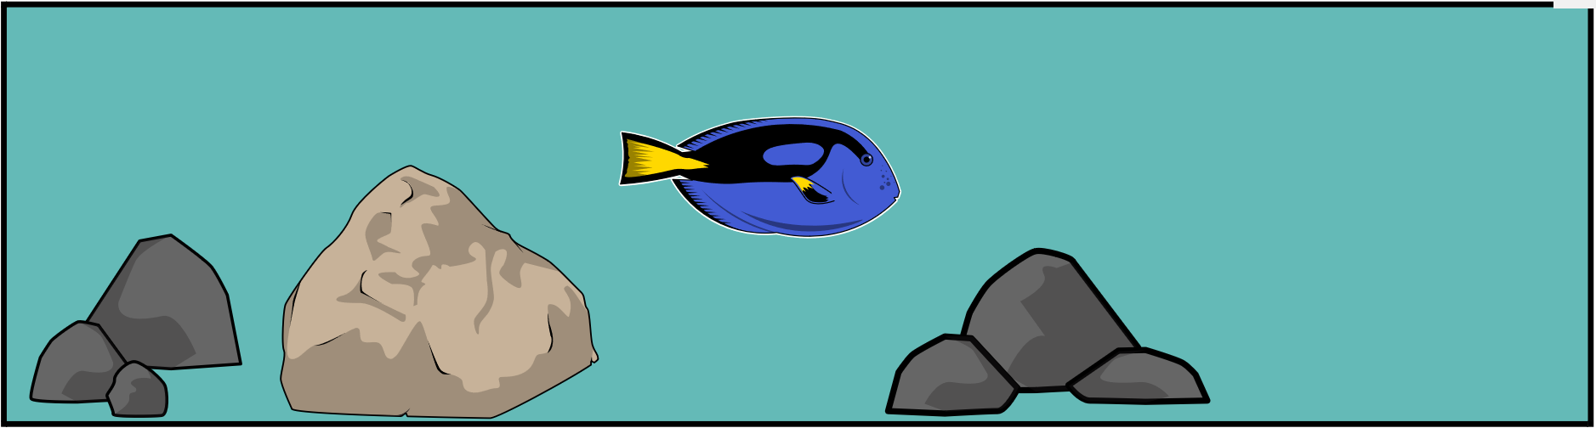

Say “Hi” Dimmy!

2
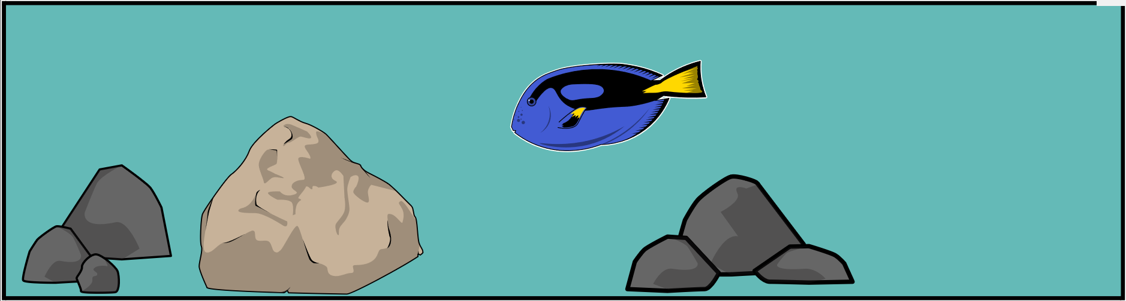

Dimmy is a little blue fish.
His brain is much smaller than he is.

Dimmy is not the smartest fish in the sea.
Definitely not as smart as you. You have a much bigger brain!

3
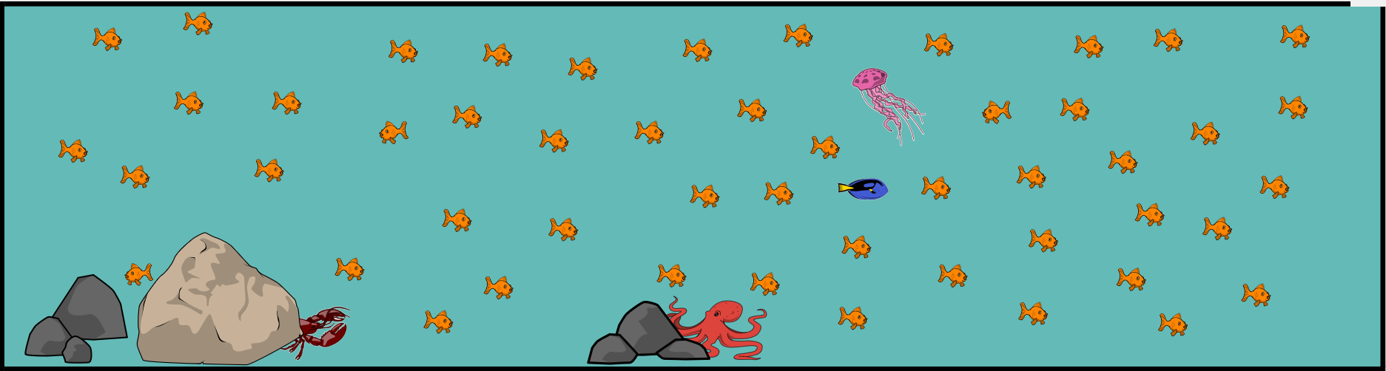

Dimmy is also different from the other little fishies.
He is pretty blue. The others are shiny orange.

The other little fishies really like Dimmy.
He is quite a catch and swims really fast.

4
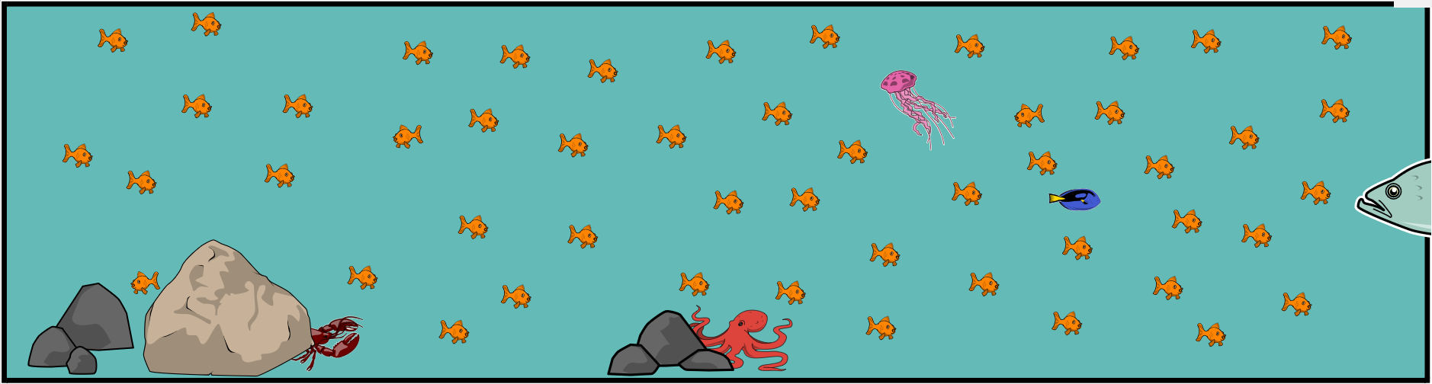

One day a really big fish nicknamed “Tuni the Terrible” showed up.
Ahhhhhh! Do you see him coming, to the right?

All of the little fishies got scared.
Why? Because Tuni the big fish looked really hungry.

5
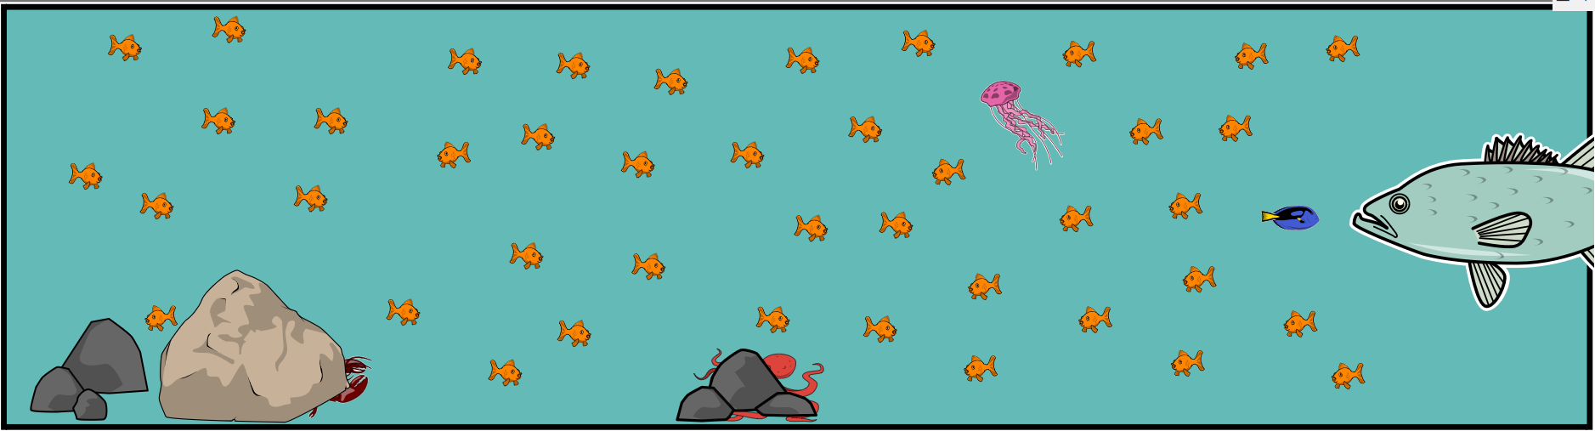

REALLY, REALLY hungry!
He started eating the little fishies! Holy mackerel!

“It’ breakfast time!” shouted Tuni the big fish.
“Stop that!” Dimmy demanded.

6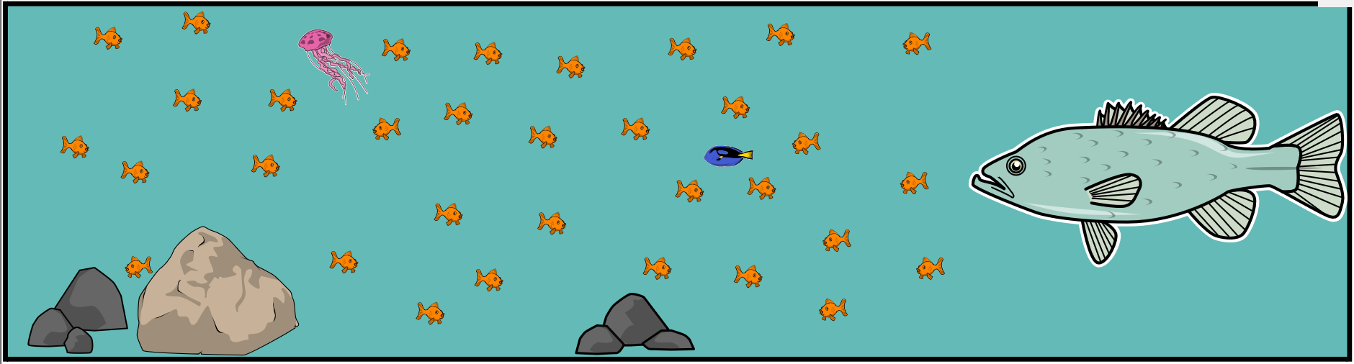

Well, that did not work.
Tuni the big fish kept eating little fishies.

“It’s lunch time!” shouted Tuni even louder.
“Save yourselves,” yelled Dimmy!

7
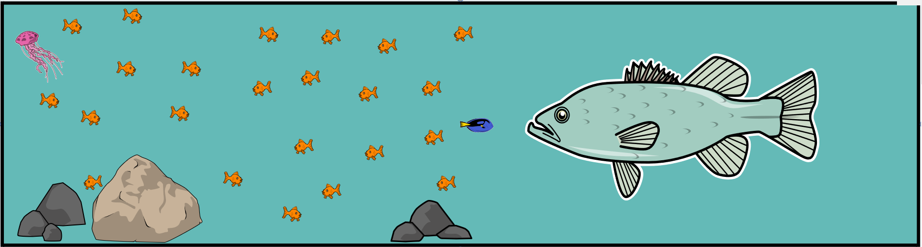

Tuni the big fish would not stop. He kept eating little fishies.
“Stop it, right now!” shouted Dimmy again.

“No, it’s dinner time!” replied Tuni.
“YIKES, he is terrible!” thought Dimmy. “Hurry, save yourselves little fishies! It’s a fish eat fish world out there.”

8

“What in the wet world are we going to do?” asked the little fishies.
“I don’t know,” replied Dimmy.

“But, there are twelve of us and only one of him,” exclaimed a little fish.
“Why does that matter?” asked Dimmy.
9
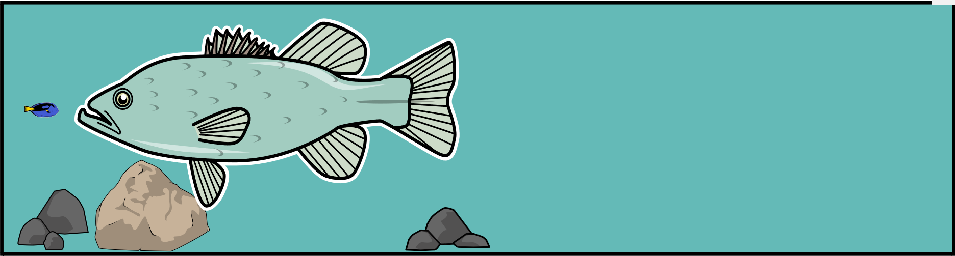

No one answered. Uh, oh!

Now it was just Dimmy and Tuni (the lobster and octopus were still hiding behind the rocks).
But Dimmy was a little less scared because the much bigger fish already ate his breakfast, lunch, AND dinner.

“Let me see,” said the big fish. “What’s left for dessert?”

10

Say “bye” Dimmy.

Quite a catch, he was!

Conclusion

“I’ll never under…stand,” thought Tuni the terrible as he burped.
“There are so many of them,
And only one of me.

If they just worked together,
their problem could be solved.
And I would not be getting so big.

Oh, well. I need to find more food.”

The end!
(of Dimmy and the Little Fishies)

Check for Comprehension

- Did Dimmy and the little fishies work alone or as a group? Where in the story does it show this?

- Did Dimmy and the little fishies work cooperatively? Where in the story does it show this?

- What were the consequences of their choices? Where in the story does it show this?

Activity 2: You be the Illustrator
Hey readers!
Are you smarter than Dimmy?
Pretend that you were Dimmy but use your bigger brain!
In the scene below, draw what Dimmy and the little fishies could have done to save themselves from the big fish “Tuni the Terrible”.
Be creative! Color your new scene.

Activity 3: You be the Author
Explain what Dimmy with your big brain could have said when the little fishies turned to him for help.

“What in the water are we going to do?” asked the little fishies.

“___________________________________________________,” replied Dimmy (with your big brain).

Activity 4: Listen to the story of Swimmy by Leo Lionni at
https://www.youtube.com/watch?v=BDrR78REU8Y

You are about to listen to a story called Swimmy by Leo Leonni. The story is just like the story of Dimmy but Swimmy and the little fishies will make different choices. Are their choices better?

Swimmy
Written and illustrated by Leo Lionni (a “big fish”)
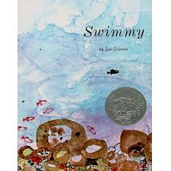

Check for Comprehension (after listening to the story)

- Did Swimmy and the little fishies work alone or as a group? Where in the story does it show this?

- Did Swimmy and the little fishies work cooperatively? Where in the story does it show this?

- What were the consequences of Swimmy’s and the little fishies’ choices? Where in the story does it show this?

Decide: Is it better to work alone or cooperatively in groups? Explain.

Activity 5: Learn How to Work Well in Groups
The stories of Dimmy and Swimmy show why it is sometimes wise to work in groups. But it’s not enough just to get into groups. There are three things that we can do in groups to make them work well.

- Define the objective. In other words, decide what the group wants to do. Think – what did Swimmy and the little fish want to do?

- Divide responsibilities. Decide who will do which jobs. What did Swimmy do? What did the other little fish do?

- Work cooperatively. Do what you are supposed to do and help others do what they are supposed to do. Explain how Swimmy and the other little fishies cooperated?

Activity 6: Take Informed Action
Choose a project that you can do at home (e.g. clean your home, clean up the area around you house, build something, solve a problem). Ask people in your home to help. Then…
- Define your objective: Decide what your group wants to do.
- Divide responsibilities: Decide who will do which jobs.
- Work collaboratively: Do your part and help others do their parts.

