Social Studies Home Learning Activities

Standard Benchmark  Civics 3 | Students will understand that citizens are individually responsible for keeping themselves informed about public policy issues on the local, state, and federal levels; participating in the civic process; and upholding the laws of the land.
Grade Band | 9-12
Vocabulary/Key Concepts | Public policy, federal, civic process

Mischief and Misinformation in Times of Crisis

Introduction
Delaware’s civics standards are designed to provide citizens with the knowledge, skills, and dispositions needed to help them (includes you) …
- be able to solve problems that you will encounter throughout life and that require some level of government support or interaction
- maintain a healthy democracy
- advocate for changes that improve the lives of all Americans

To achieve this, students should be offered opportunities to engage in activities that actually help you develop civic knowledge, skills and dispositions. Such activities should involve…
- Becoming and remaining informed about public policy issues
- Participating in civic processes, and
- Upholding the laws of the land.

The COVID-19 pandemic offers an authentic context for all Americans to develop as highly effective citizens.

Focus Question: Why should Americans fulfill their responsibilities as citizens?

This work was developed by the University of Delaware’s Democracy Project. View Creative Commons Attributions at https://creativecommons.org/licenses/by-nc-sa/4.0/

Activity 1: Fact Checking “Excessive Delaware”
Hypothetical Scenario for this Activity
Posts appearing on a controversial “Excessive Delaware” website (see Section 1 below) appear to be the work of malicious individuals or groups attempting to undermine public support for elected officials in our state. Their long-range goal is to divide Americans on opposite sides of the political spectrum - people who have banded together in amazingly collaborative ways during this crisis to ensure the well-being of Delaware’s citizens. Those behind the posts appear to be foreign trollers who have been working for years to undermine faith in American democracy.
Some of the information found on the “Excessive Delaware” posts appears below. Read the information then fact check using real Delaware COVID-19 State of Emergency declarations to determine which social media posts are fact, and which are “fake news”.
Compile a report for the Governor that distinguishes the facts from the fakes so that the public can be informed about the mischief and misinformation. The information needed to identify misinformation can be found below the posts.

Document 1
Posts Found on the “Excessive Delaware” Website Dealing with
the COVID-19 State of Emergency
Post 1: As of April 16, 2020, over 2,000 Delawareans have died from the coronavirus.
Post 2: Most of the Delawareans who have tested positive for the coronavirus are between the ages of 18-49.
Post 3: The heaviest concentrations of infections are along the Delaware beaches.
Post 4: Delaware schools remain closed until May 15th. No school district or charter school shall extend its school calendar beyond the end of June.
Post 5: Stores in Delaware may not allow more than 20 people inside at any time.
Post 6: Police will enforce the limits as people try to enter the doors.
Post 7: Stores are not permitted to offer self-serve foods.
Post 8: Public gatherings are limited to 10 people through May 31st.
Post 9: No more than 10 people may attend weddings or funerals until the public health threat has been eliminated.
Post 10: Nursing facilities that care for the elderly must set aside separate areas for any new persons admitted to the facilities.
Post 11: Leaders of one political party are issuing emergency orders that only benefit the interests of their own party’s members.
Post 12: Delawareans who own vacation homes may not rent them for short periods until the emergency orders are lifted.
Post 13: Church services are prohibited until the ban is lifted.
Post 14: The following “non-essential businesses” are to remain closed until the ban is lifted: casinos, racetracks, sporting events, bowling alleys, indoor skating rinks, swimming pools, libraries, bookstores, pharmacies.

This work was developed by the University of Delaware’s Democracy Project. View Creative Commons Attributions at https://creativecommons.org/licenses/by-nc-sa/4.0/

Document 2
Official Reporting Form
After fact checking the information posted on the “Excessive Delaware” website, indicate which posts are factual and which contain misinformation. The report should correct any cases of misinformation.
Post 1: Credible or Misinformation (circle one). Correct below if misinformation.
_______________________________________________________________________________
Post 2: Credible or Misinformation (circle one). Correct below if misinformation.
_______________________________________________________________________________
Post 3: Credible or Misinformation (circle one). Correct below if misinformation.
_______________________________________________________________________________
Post 4: Credible or Misinformation (circle one). Correct below if misinformation.
_______________________________________________________________________________
Post 5: Credible or Misinformation (circle one). Correct below if misinformation.
_______________________________________________________________________________
Post 6: Credible or Misinformation (circle one). Correct below if misinformation.
_______________________________________________________________________________
Post 7: Credible or Misinformation (circle one). Correct below if misinformation.
_______________________________________________________________________________
Post 8: Credible or Misinformation (circle one). Correct below if misinformation.
_______________________________________________________________________________
Post 9: Credible or Misinformation (circle one). Correct below if misinformation.
_______________________________________________________________________________
Post 10: Credible or Misinformation (circle one). Correct below if misinformation.
_______________________________________________________________________________
Post 11: Credible or Misinformation (circle one). Correct below if misinformation.
_______________________________________________________________________________
Post 12: Credible or Misinformation (circle one). Correct below if misinformation.
_______________________________________________________________________________
Post 13: Credible or Misinformation (circle one). Correct below if misinformation.
_______________________________________________________________________________
Post 14: Credible or Misinformation (circle one). Correct below if misinformation.
_______________________________________________________________________________

The Governor has asked that you prepare a statement that you will be asked to use during tomorrow’s press briefing. He wants you to use the statement to explain the issues with the “Excessive Delaware” website and emphasize why it is so important at this moment in time for Delawareans to fulfill their responsibilities as citizens.

Press Briefing Statement

____________________________________________________________________________________________________________________________________________________________________________________________________________________________________________________________________________________________________________________________________________________________________________________________________________________________________________________________________________________________________________________________________________________________________________________________________________________________________________________________________________________________________________________________________________________________________________________________________________
________________________________________________________________________________________________________________________________________________________________________________________________________________________________________________

Section 2: Official Government Information Relating to COVID-19 Data and Policies in Place Until the Public Health Threat has been Eliminated or Policies are Lifted.
Use the information below to fact-check information that is posted on the “Excessive Delaware” site.
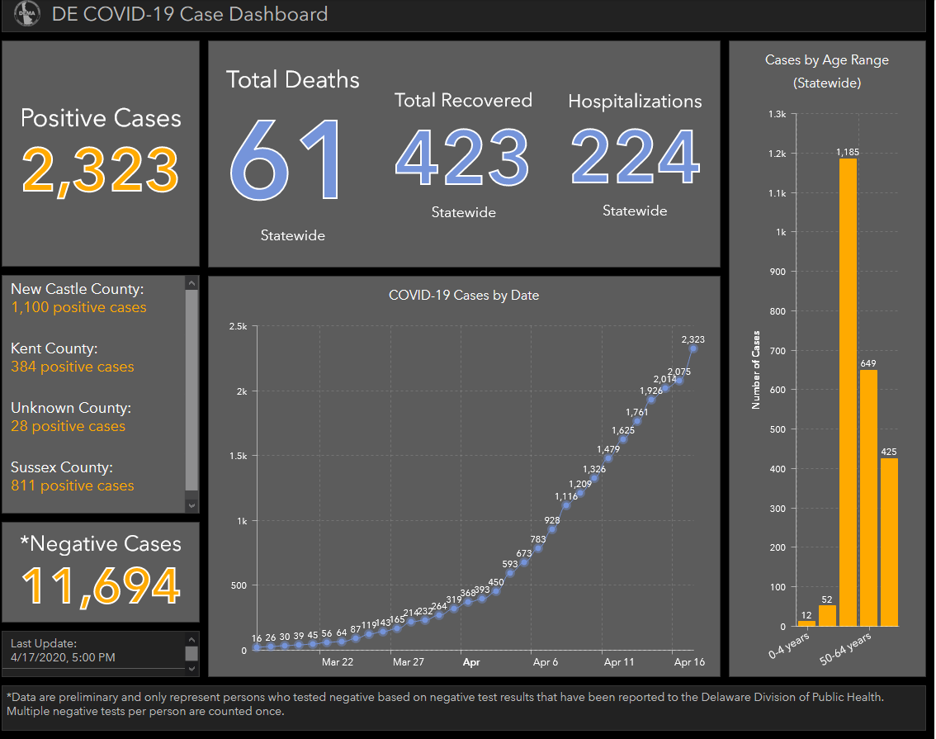

Figure 1: Coronavirus Statistics for the State of Delaware through April 16.
Source: Delaware Division of Public Health, Coronavirus Response at https://coronavirus.delaware.gov/ Check regularly for updates.

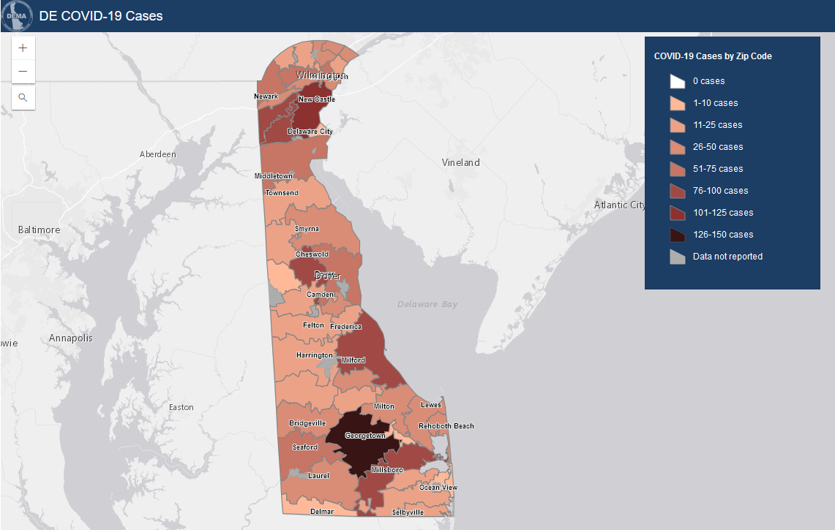
Figure 2: Map of Confirmed Coronavirus Cases in Delaware
Source: Delaware Division of Public Health, Coronavirus Response at https://coronavirus.delaware.gov/ Check regularly for updates.

Actual Excerpts from Delaware’s COVID-19 State of Emergency Declaration and Modifications
State of Emergency Orders involving Schools in Delaware
Governor John Carney ordered all Delaware schools to remain closed through at least Friday, May 15 to fight the spread of coronavirus (COVID-19).
“On March 13, after significant discussion with superintendents and charter school leaders, I ordered public schools to close through this Friday, March 27,” said Governor Carney. “This two-week period was intended to help school leaders and educators plan for what came next.
“We have spent a significant portion of the last week discussing plans for remote instruction, the delivery of meals, and other social services. This is an unusual time – but children still deserve access to a quality education, and families rely on the social services we deliver in our schools every day. We’ll continue to work directly with school leaders on these important issues.”
Governor Carney also announced the following:
- The State of Delaware intends to formally recommend that no school district or charter school extend its school calendar beyond the end of June. Dr. Susan Bunting, Secretary of the Delaware Department of Education, will formally make that recommendation to the State Board of Education, upon submission by each district and charter.
- The State of Delaware has submitted a waiver to the U.S. Department of Education requesting Delaware be exempt from state testing this year to focus our efforts on student instruction.

Fourth and Fifth Modifications to the Governor’s State of Emergency Declaration
Delawareans are ordered to stay at home whenever possible and all non-essential businesses in Delaware are closed to help fight the spread of COVID-19.

Ninth Modification to the Governor’s State of Emergency Declaration
Governor Carney’s modified emergency order limits public gatherings to 10 people through May 15, or until the public health threat has been eliminated. For the purposes of the order, public gatherings include weddings, funerals, and related activities.
The order also requires new action from businesses that remain open. Under Governor Carney’s modified emergency order, businesses must:
- Allow no more than 20 percent of stated fire capacity in the store at any given time – and no more than 10 percent during exclusive hours for high-risk populations.
- Clearly mark six-foot spacing in checkout lines and other high-traffic areas, including outside.
- Discontinue any self-serve foods, or product sampling.
- Designate staff to enforce the number of people coming into the store and enforce limits.

Tenth Modification to the Governor’s State of Emergency Declaration
Governor John Carney on Monday issued the tenth modification to his State of Emergency declaration, banning all short-term rental units – including vacation home rentals, hotels, motels, and condo rentals – to help fight the spread of COVID-19.

Commercial lodging in Delaware will remain closed through May 15, or until the public health threat is eliminated. The order exempts certain Delawareans and essential workers who may need access to short-term rental units. That list of exemptions includes caretakers with family members nearby, health care providers, journalists, and Delawareans with public housing vouchers.
Victims of domestic violence who need alternative shelter also are exempted.
Monday’s order places additional restrictions on businesses, banning door-to-door solicitation and closing pawn shops, video game stores, and other electronics retailers.
Houses of worship and other places of religious expression or fellowship, which shall comply with all social distancing requirements set forth in the COVID-19 State of Emergency declaration and all modifications, including attendance of no more than 10 people for in-person services under any circumstances. Houses of worship are strongly encouraged to transition any in-person services to remote services broadcast by telephone or video.
Non-Essential Businesses: Non-Essential Businesses as used herein means:
1. Hospitality and Recreation Facilities, which shall include without limitation:
a. Indoor community and recreation centers;
b. Casinos and racetracks
c. Sporting facilities and venues (professional and amateur), including but not limited to arcades, bowling alleys, indoor skating rinks (ice and non-ice), martial arts studios, dance studios, indoor tennis and similar indoor athletic facilities;
d. Gyms, including yoga, barre and spin facilities and other indoor fitness facilities;
e. Swimming facilities (public or community);
f. Indoor play areas;
g. Concert halls and venues;
h. Theaters and performing arts venues;
I. Zoos; and
j. Museums;

2. Hair salons, barber shops, nail salons, and spas;
3. Pawn shops;
4. Door to door solicitations;
5. Customer service call centers and telemarketing operations;
6. Shopping malls, except that Essential Businesses and Limited Operation Non-Essential Businesses that are directly accessible through stand-alone exterior access points may remain open, subject to applicable requirements;
7. Electronics retailers;
8. Video, video game, or computer game rental or similar retail;
9. Craft or hobby retailers;
10. Libraries and bookstores;
11. Ice cream, water ice, custard, or similar shops (except for service by drive-thru), and ice cream trucks;

Eleventh Modification to the Governor’s State of Emergency Declaration
Governor Carney’s order requires all nursing facilities in Delaware to immediately:
- Establish a cohort of staff who are assigned to care for known or suspected COVID-19 residents.
- Designate a room, unit, or floor of the nursing facility as a separate observation area where newly-admitted and re-admitted residents are kept for 14 days on, while being observed every shift for signs and symptoms of COVID-19.
- Designate a room, unit, or floor of the nursing facility to care for residents with known or suspected COVID-19.
Stay Informed! Visit here or copy and paste https://coronavirus.delaware.gov/ into your browser to receive updates on Coronavirus developments in Delaware.

