Social Studies Home Learning Activities

Standard Benchmark | Students will understand that leaders are sometimes chosen by election, and that elected officials are expected to represent the interests of the people who elected them.
Grade Band | K-3
Vocabulary/Key Concepts | Leader, Election, Representative

Focus Question #1: Should Leaders be Elected?

Activity 1
Define the word “leader”. Think about people you know who are good leaders. Write down some characteristics of a good leader.

Activity 2
Create a list of four famous book or movie characters who are good leaders. Pretend that you have been assigned the task of picking one character to be the leader of all other characters.

List of Good Leaders in Book or Movies
- _____________________________
- _____________________________
- _____________________________
- _____________________________
Activity 3
See the chart below. Try several methods for choosing the leader from your list. Add others if you want. Which method seemed best?

Method for Who Became Was it a Good Choosing the Leader? or Bad Method?

Coin Flip ___________________ Good or Bad
Explain why: ____________________________________________
_____________________________________________________

Appointment ___________________ Good or Bad
Explain why: ____________________________________________
_____________________________________________________

Draw a Name ___________________ Good or Bad
Out of a Hat
Explain why: ____________________________________________
_____________________________________________________

Pick the Smartest ___________________ Good or Bad
Explain why: ____________________________________________
_____________________________________________________

Have an Election ___________________ Good or Bad
Explain why: ____________________________________________
_____________________________________________________
Which method for choosing a leader do you think is best. Explain why.
_______________________________________________________________________________________________________________________________________________________________

Activity 4
Watch a movie such as Shrek the Third or read a book based on the movie. Which method for selecting a leader is used in the Land of Far, Far Away. Was it a good method? Explain. What method would you recommend to the people of Far, Far Away and why?

Decide: Should leaders be elected?

Focus Question #2: How Should a Representative Represent Us?

Activity 5
Two very important decisions have to be made.

The first decision – what should children be allowed to do during their free time. Here are your choices. Which one do you want to do?
- Read a book
- Draw and color pictures
- Watch a movie
- Play a game

The second decision – what should children have for a snack? Which do you want to have?
- Fruit
- Cookie
- Candy
- Soda

Activity 6 Election Time!
A representative is someone who acts of speaks for other people. People who are representatives are often leaders.

Election #1
Imagine that you have an opportunity to choose a representative who will make decisions for you. Here are your choices.

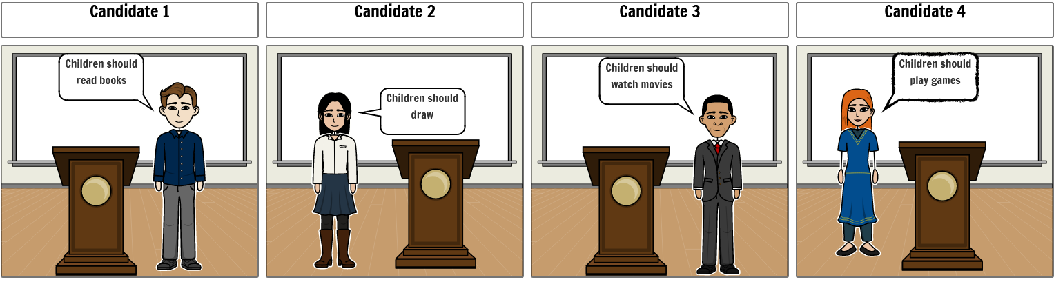

- Circle the person who you choose to represent you? Explain why.
__________________________________________________________________________________________________________

Election #2
Now, you have an opportunity to choose a second representative who will make decisions for you. Here are your choices.

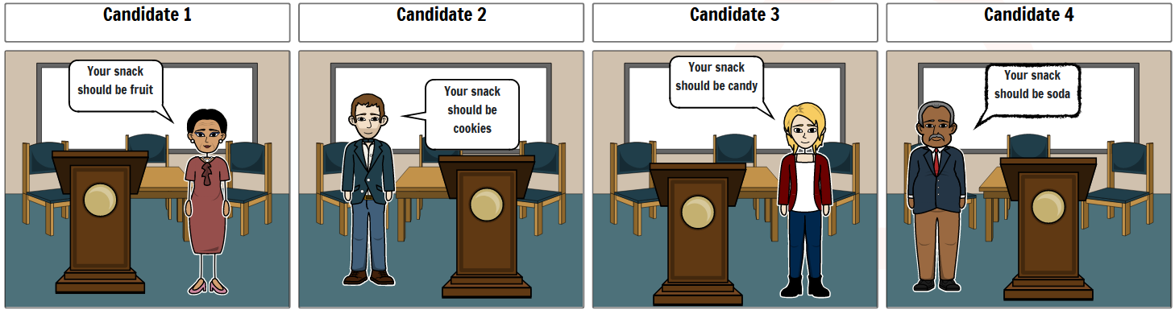

- Circle the person who you choose to represent you? Explain why.
__________________________________________________________________________________________________________
Breaking News!
The first representative that you chose voted for the same activity that you wanted. Was that person a good representative? Explain why.
__________________________________________________________________________________________________________

The second representative that you chose to represent you voted for a snack that you did not want. Was that representative a good representative? Explain why.

Good? or Bad?
__________________________________________________________________________________________________________

Now Consider This – what if the second representative chose a snack that was different from the one you wanted because the one that you wanted could make you sick. Think again. Was the representative a good or a bad representative? Explain why.

Good? or Bad?
__________________________________________________________________________________________________________

Draw Your Conclusion: how should a representative represent us?

